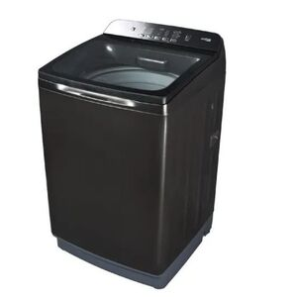

Haier 9kg-HWM 90-826-Fully Automatic-Top Load Washing Machine-Incredible Wash-10 Years Brand Warranty

* Brand Warranty
* Soaking-Washing-Rinsing-Spinning/Drying
* Incredible Wash
* Wash & Spin Capacity: 9Kg
* RPM: 1300
* Fabric Care with Pillow Drum
* Washing Convenient
* Deep Clean
* Dual Lint Filters

WASHING MACHINE